**TO SUPPLY LEFTOVER FOOD TO POOR**

SREE NARAYANA GURU COLLEGE,

K. G. CHAVADI, COIMBATORE

**College Code** : bru36

**TEAM ID** : NM2025TMID26561

**TEAM:  
      Team Leader :  
 APARNA M  
 aparnamohandas143@gmail.com**

**Team Member :**

**JOEL P JACOB**

**lifeispresious12@gmail.com**

**Team Member :  
 JAWAHARALI T A  
 jouharjoushar@gmail.com**

**INTRODUCTION**

1. **Project Overview**

Food wastage is a major problem while many people still go hungry. This project, **“To Supply Leftover Food to the Poor Using Salesforce,”** uses Salesforce CRM to connect donors, volunteers, NGOs, and receivers. The system automates food collection, tracking, and distribution with custom objects, workflows, and reports. It ensures efficiency, transparency, and real-time updates while giving students hands on experience with Salesforce and showing how technology can drive social good.

1. **Purpose**

The purpose of this project is to create a smart and efficient system that reduces food wastage and ensures that leftover food is redirected to people who need it most. In today’s world, massive amounts of edible food are discarded due to lack of proper management, while countless individuals still suffer from hunger. This project seeks to address that imbalance by building a transparent, technology-driven solution.

Through Salesforce CRM, the project connects all stakeholders—donors, drop-off points, volunteers, NGOs, and receivers—on a single platform. The system automates food collection, distribution, volunteer coordination, and reporting to make the entire process reliable, accountable, and fast. It ensures that donors can see where their contributions are going, volunteers are efficiently scheduled, and NGOs can distribute food effectively with minimal waste.

Beyond social impact, the project also serves an academic and career purpose by allowing students to gain hands-on experience in Salesforce development. Students learn to configure custom objects, workflows, triggers, and dashboards while applying these tools to solve a real-world problem. Thus, the project combines **social welfare** with **technological skill-building**, proving how CRM solutions can contribute to sustainable and impactful community service.

**DEVELOPMENT PHASE**

1. **Creating Developer Account:**

**By using this URL -** [**https://www.salesforce.com/form/developer-signup/?d=pb**](https://www.salesforce.com/form/developer-signup/?d=pb)

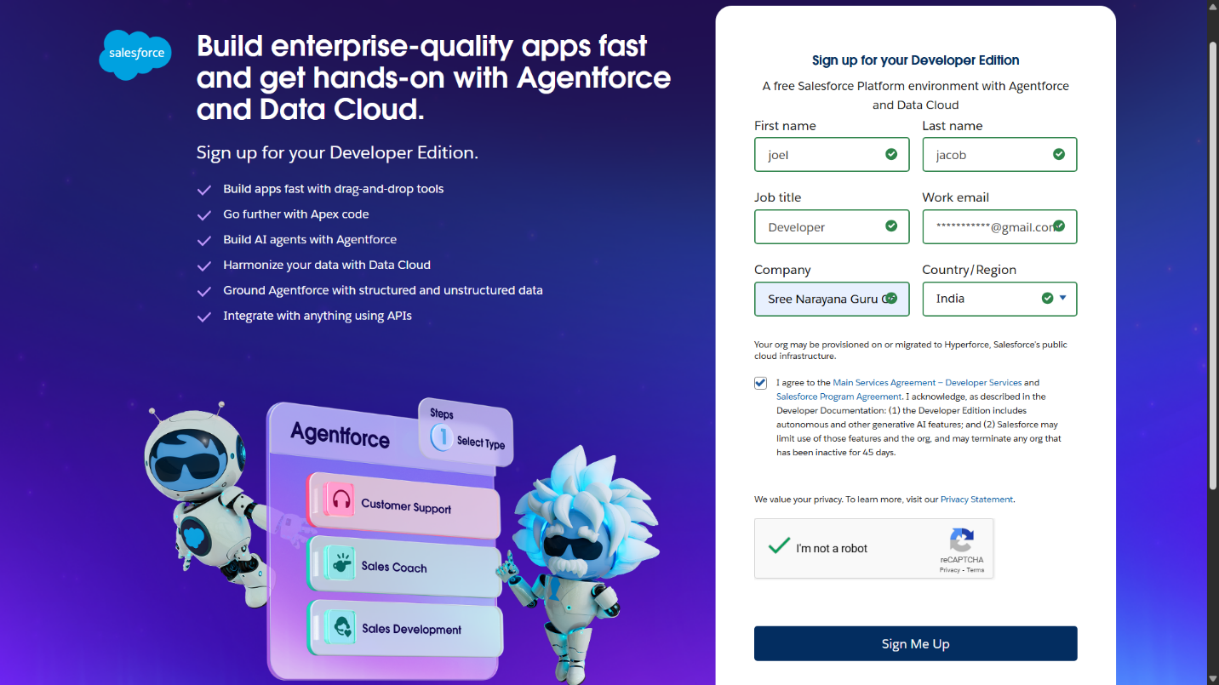

**2.Created objects: Venue, Drop-Off Point, Task, Volunteer, Execution Details**

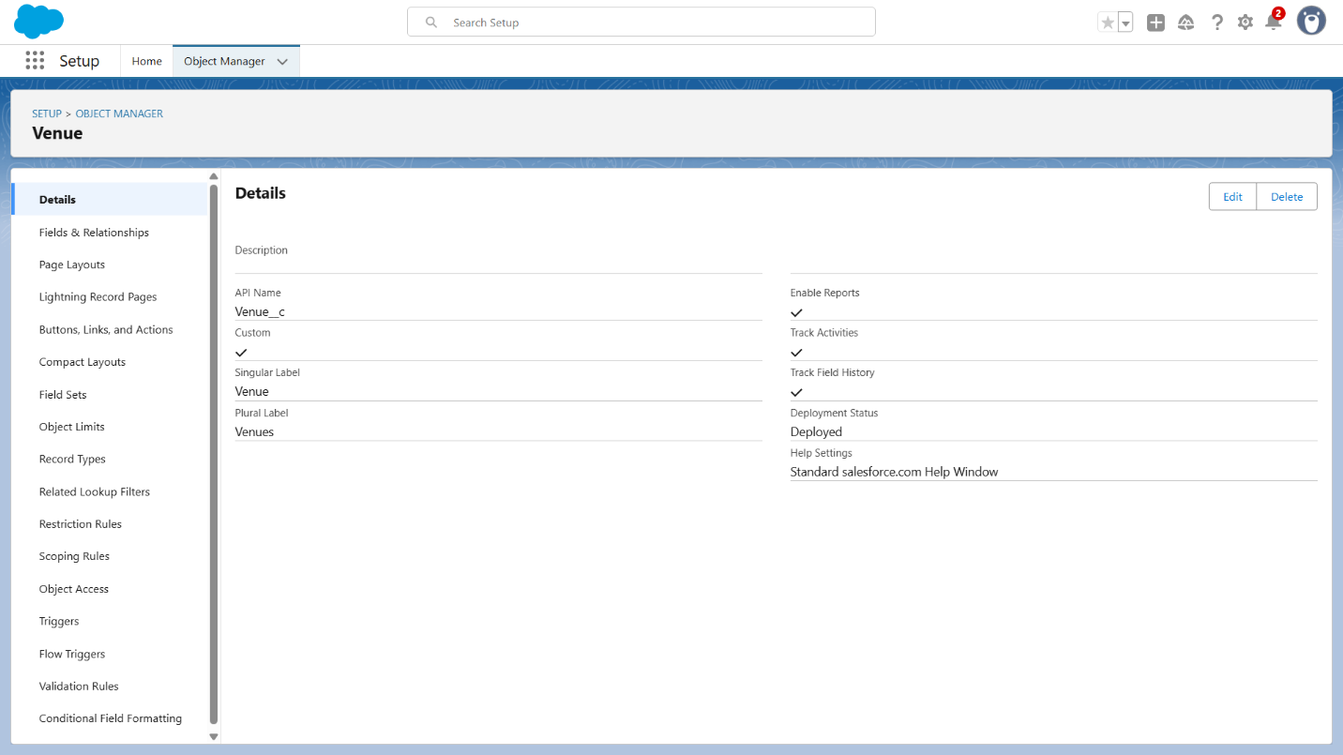

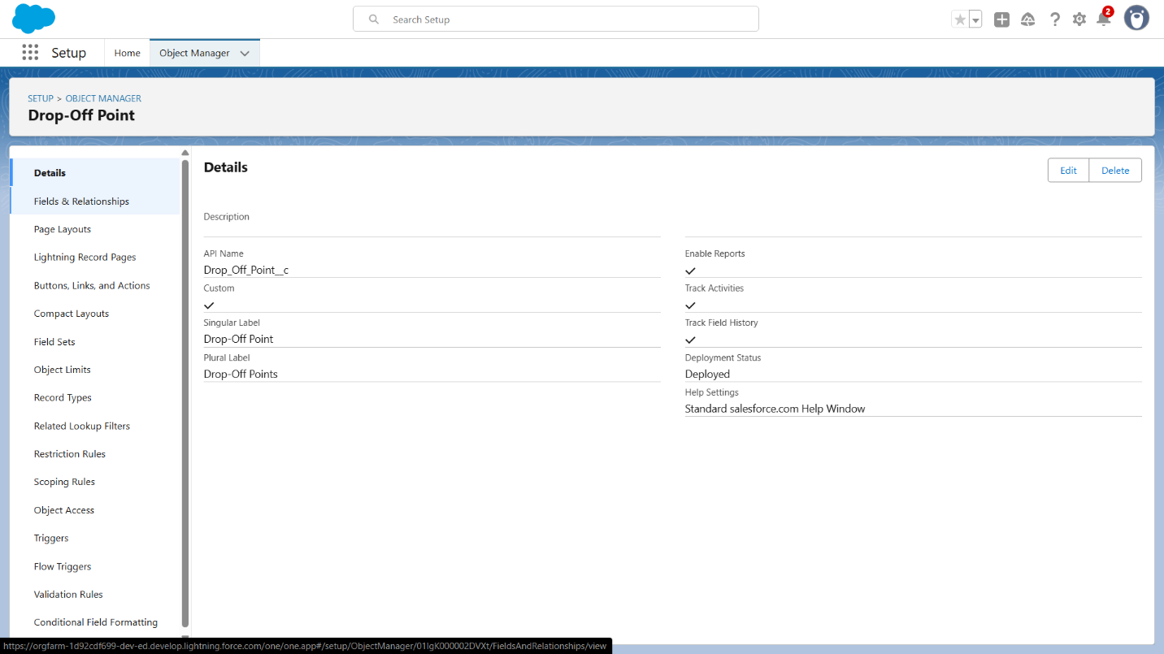

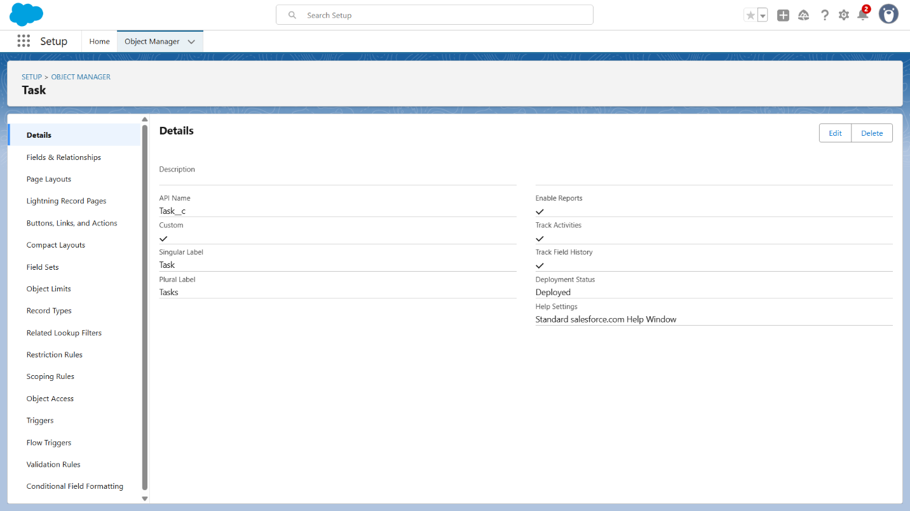

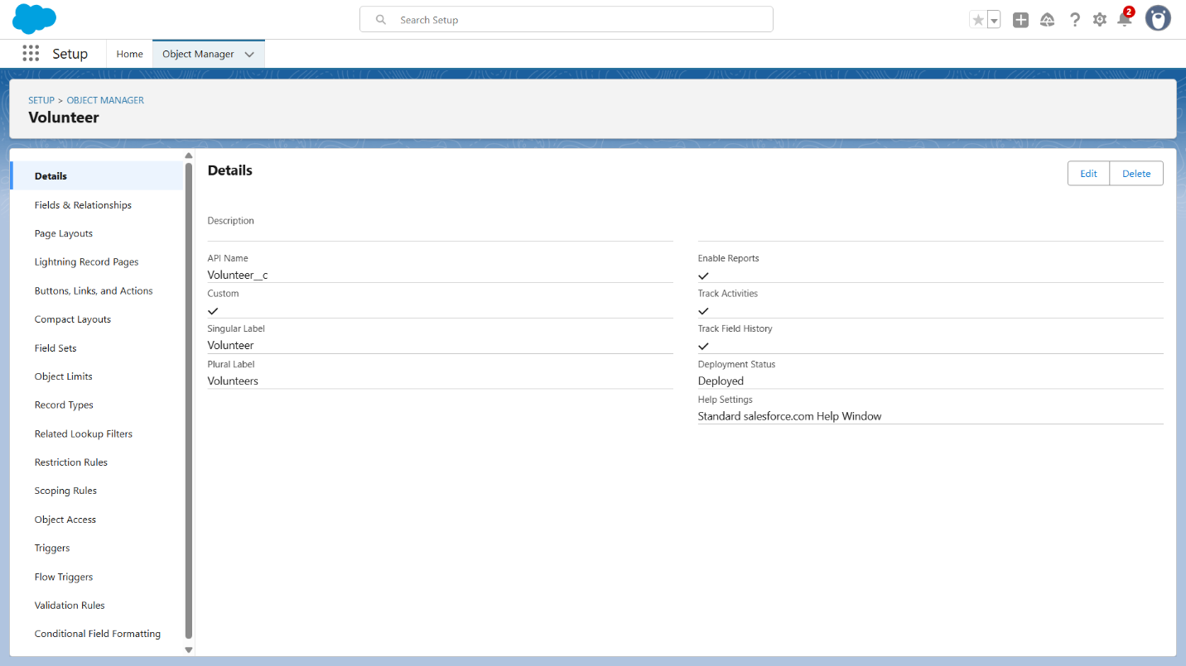

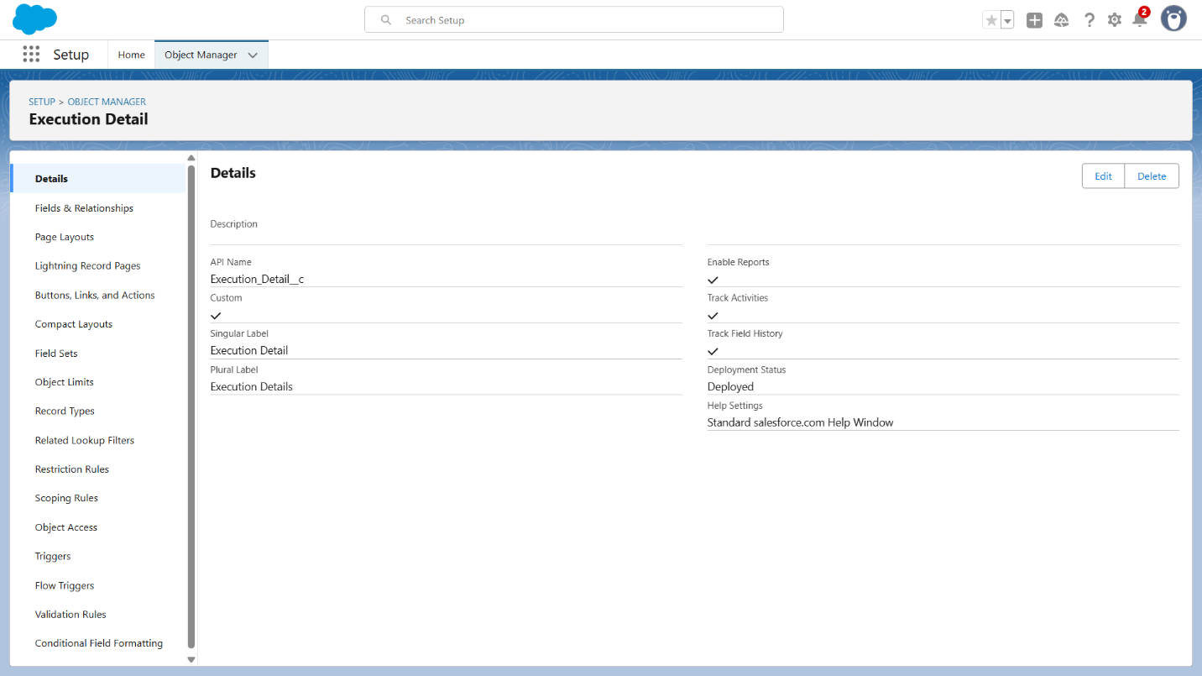

**3.Tabs**

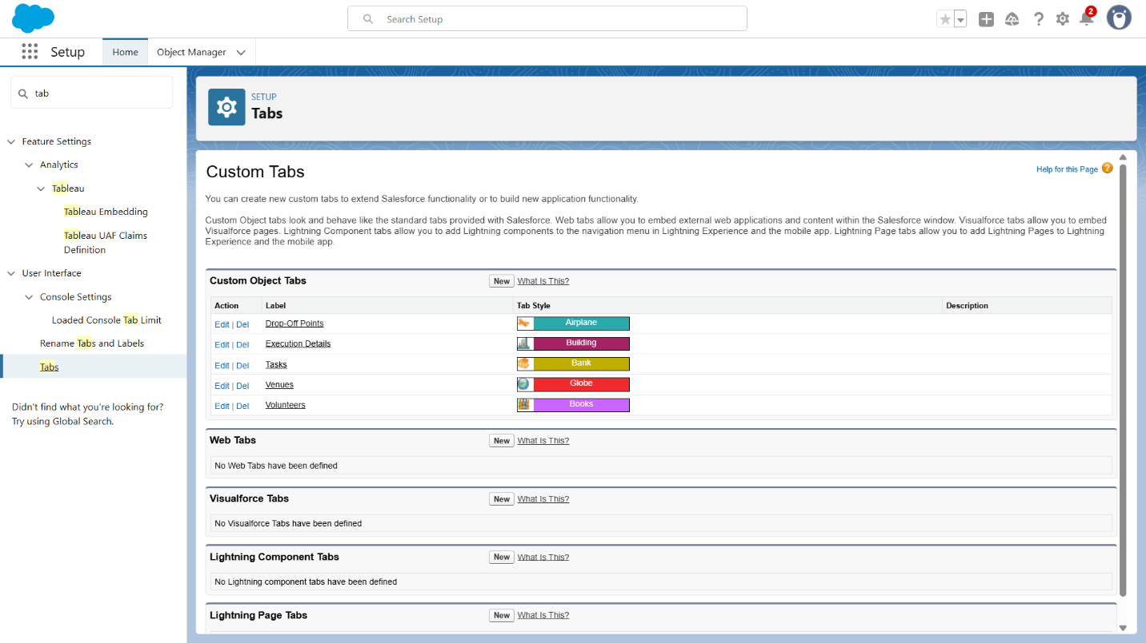

**4.Developed Lightning App**

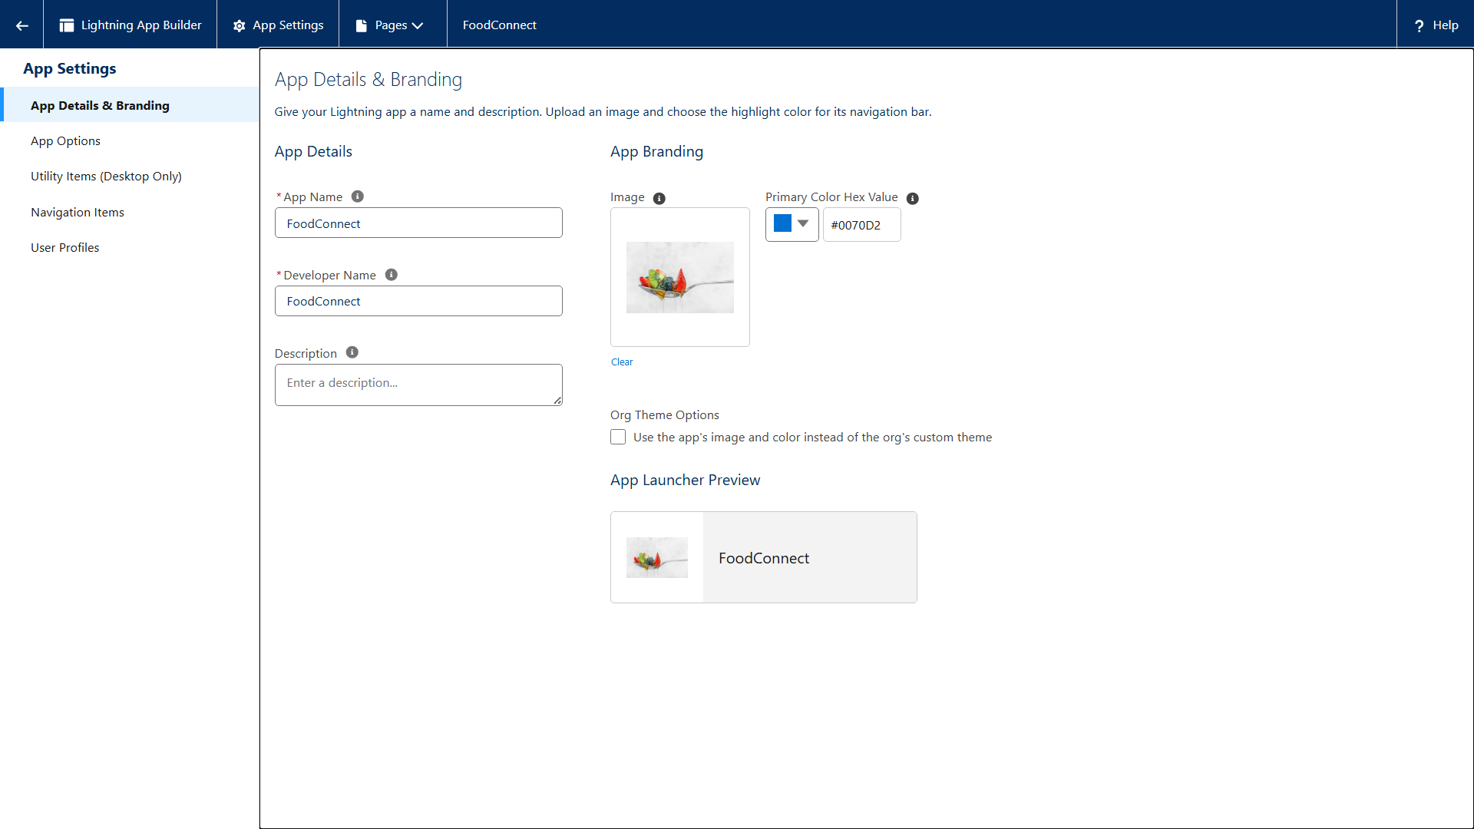

**5. Fields**

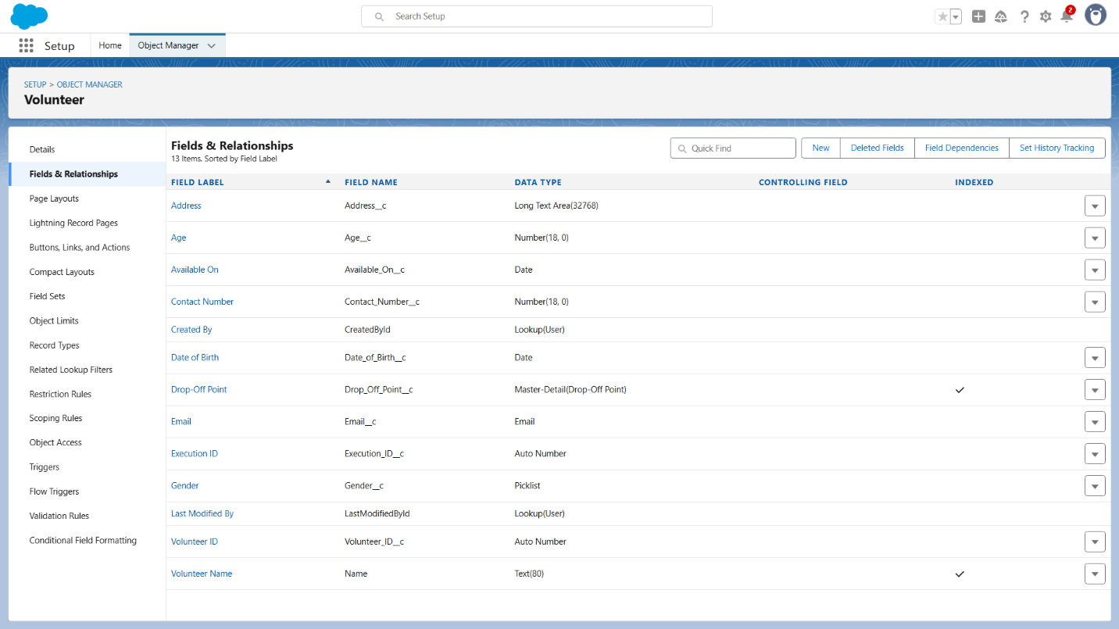

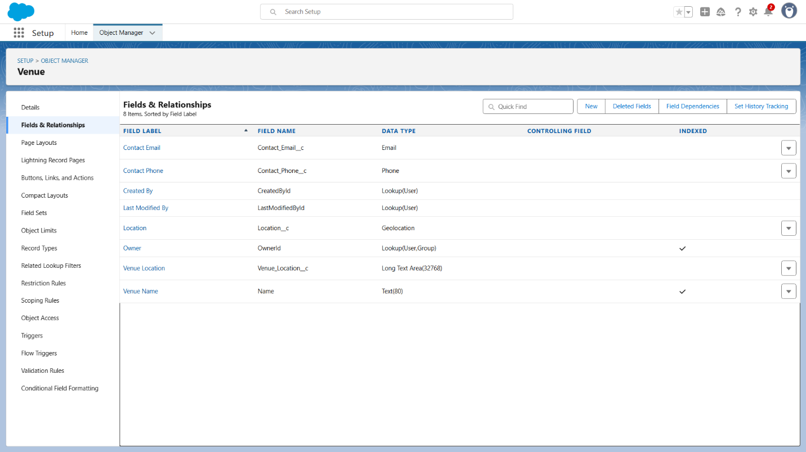

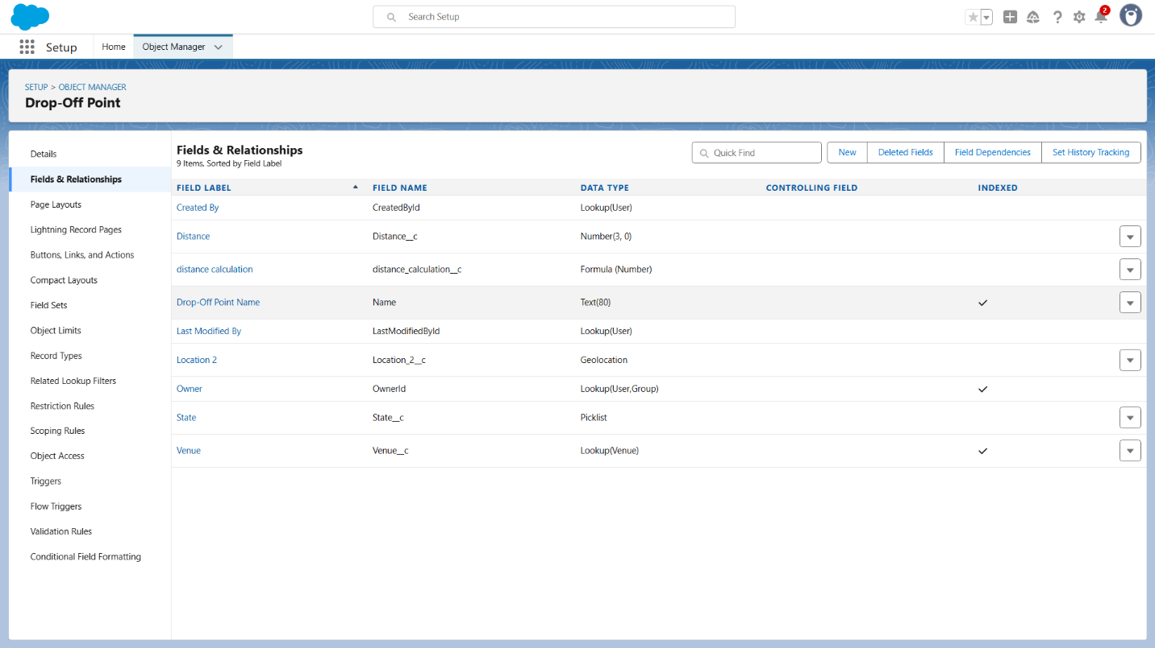

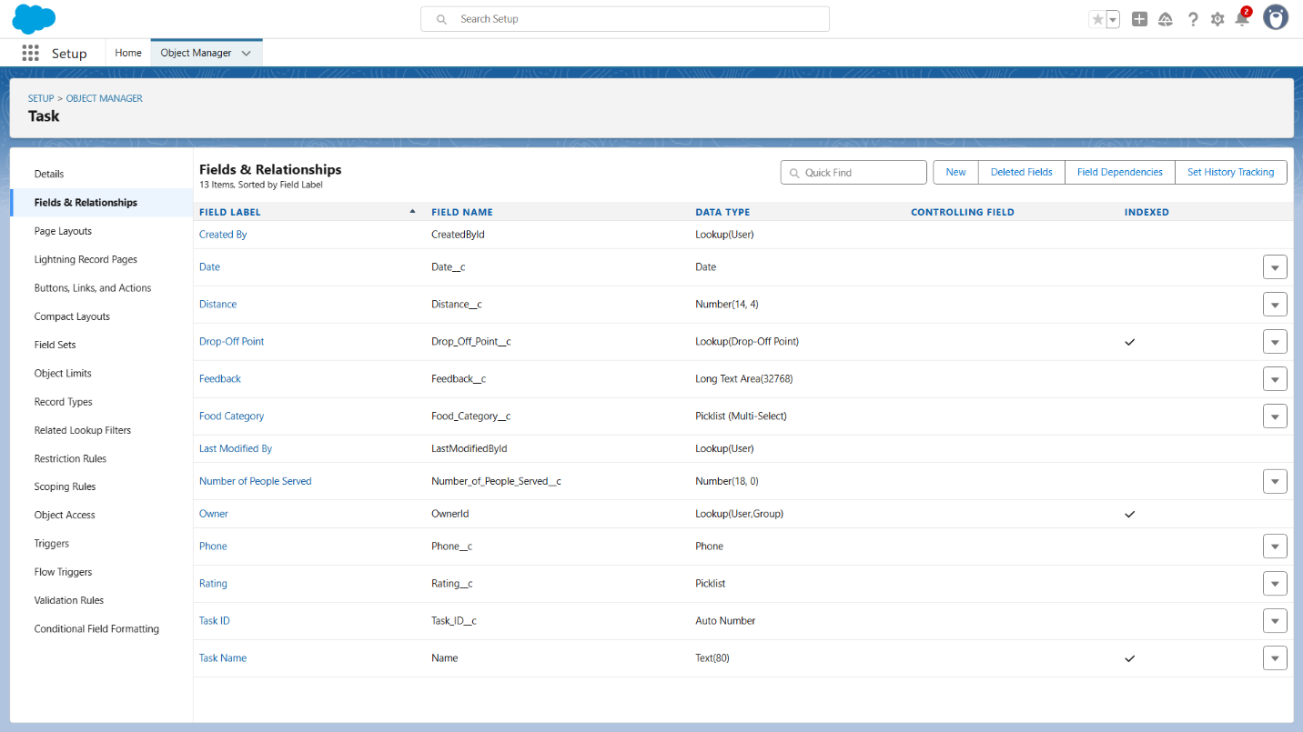

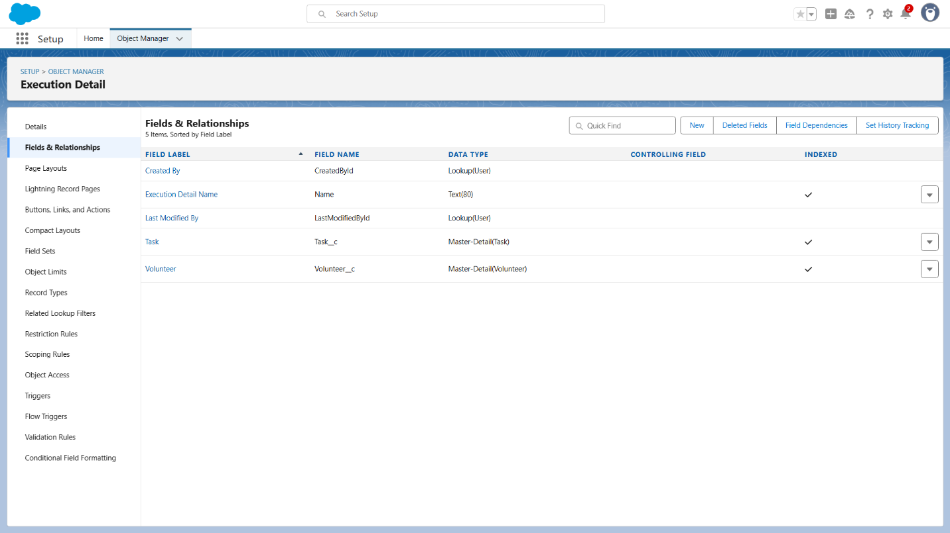

**5. Flow**

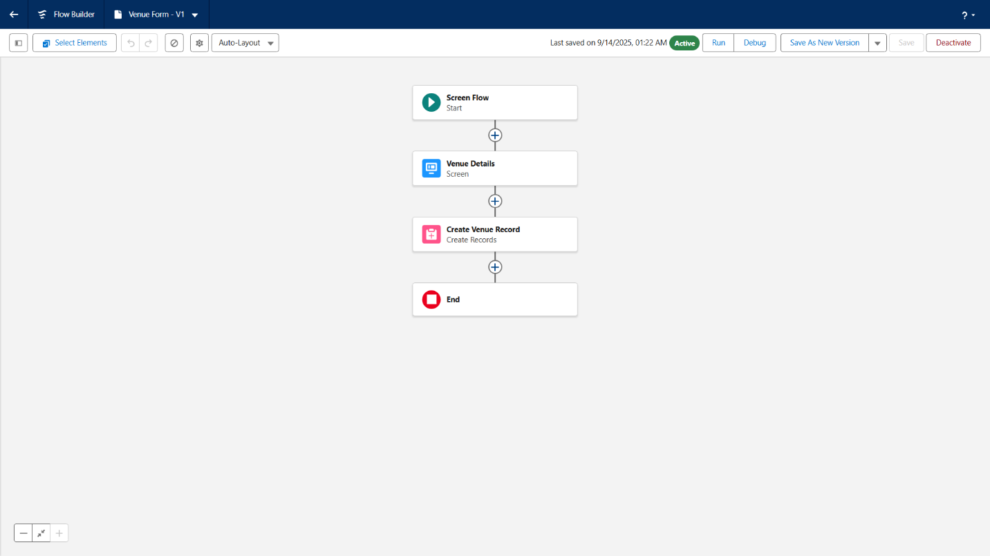

**6. Apex Trigger**

Create an Apex Trigger

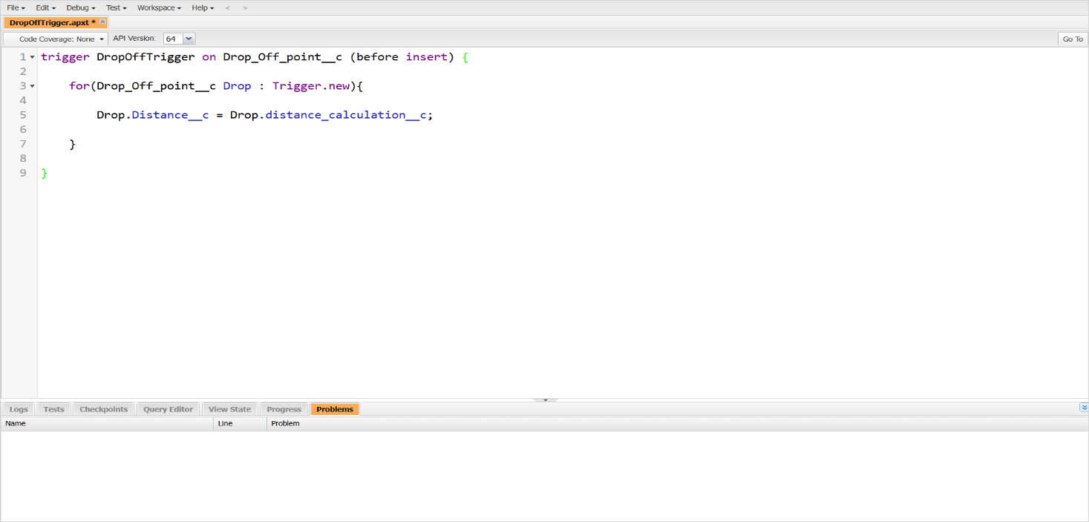

**7. Profiles**

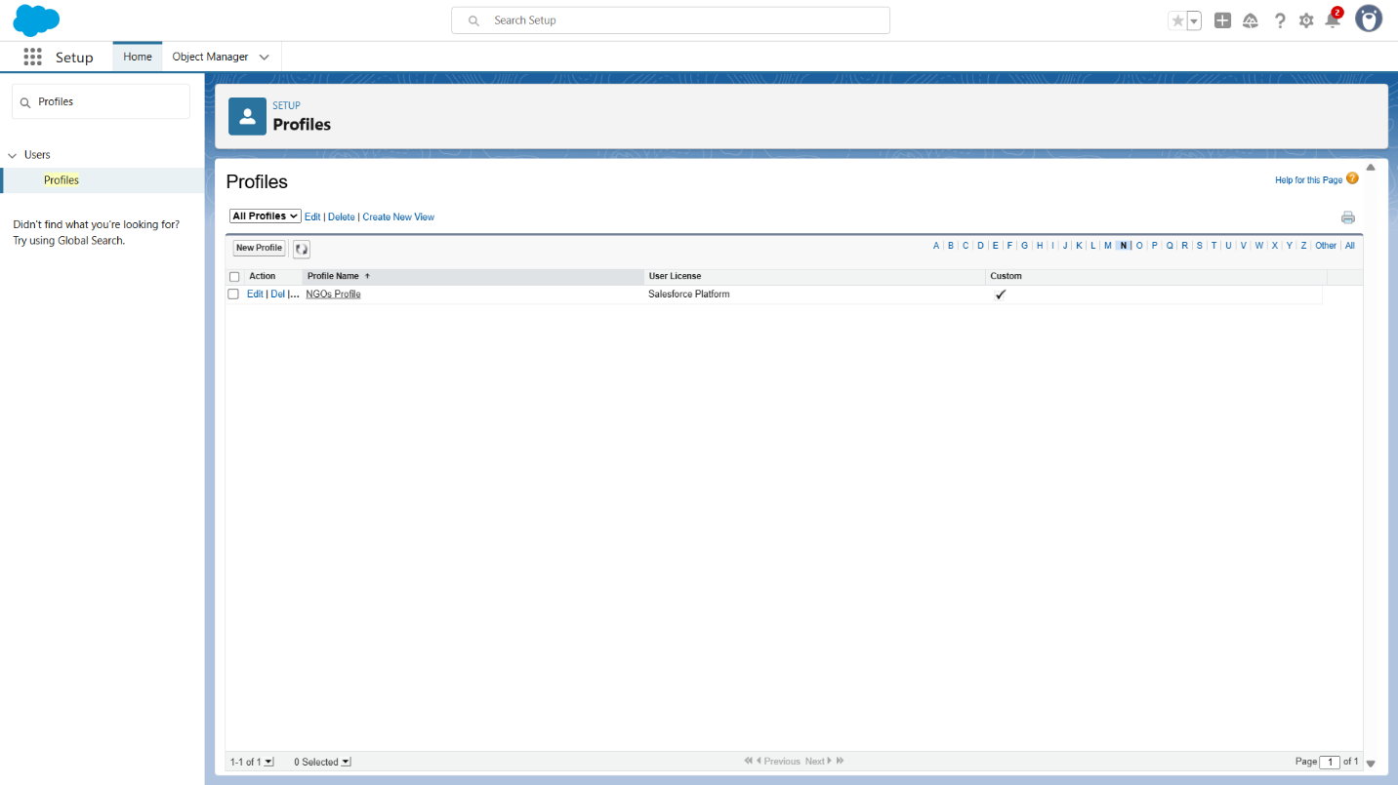

**8. Creation of Users**

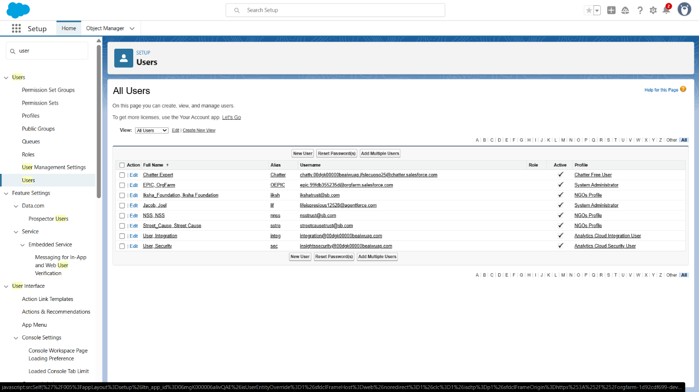

**9. Creation of Public Groups**

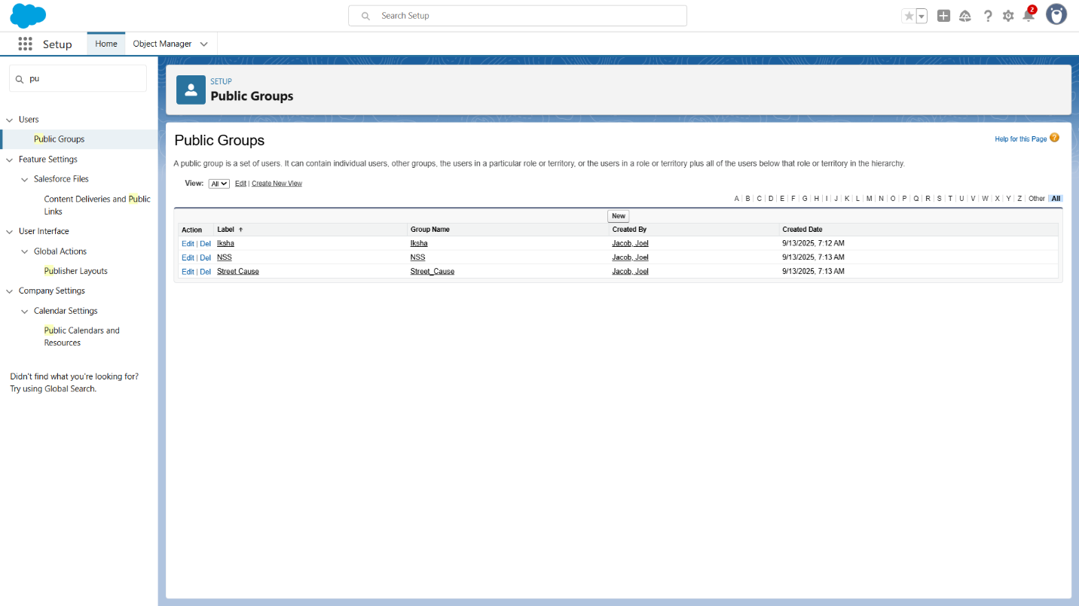

**10. Creation of Report Types**

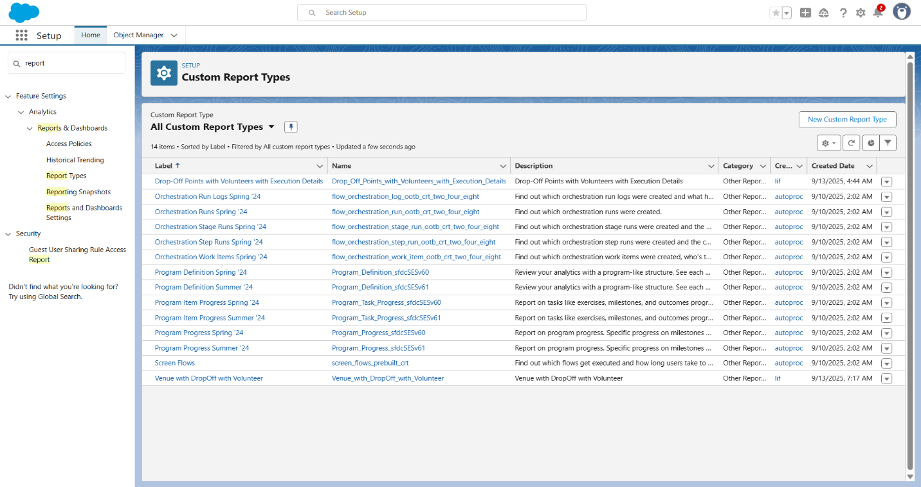

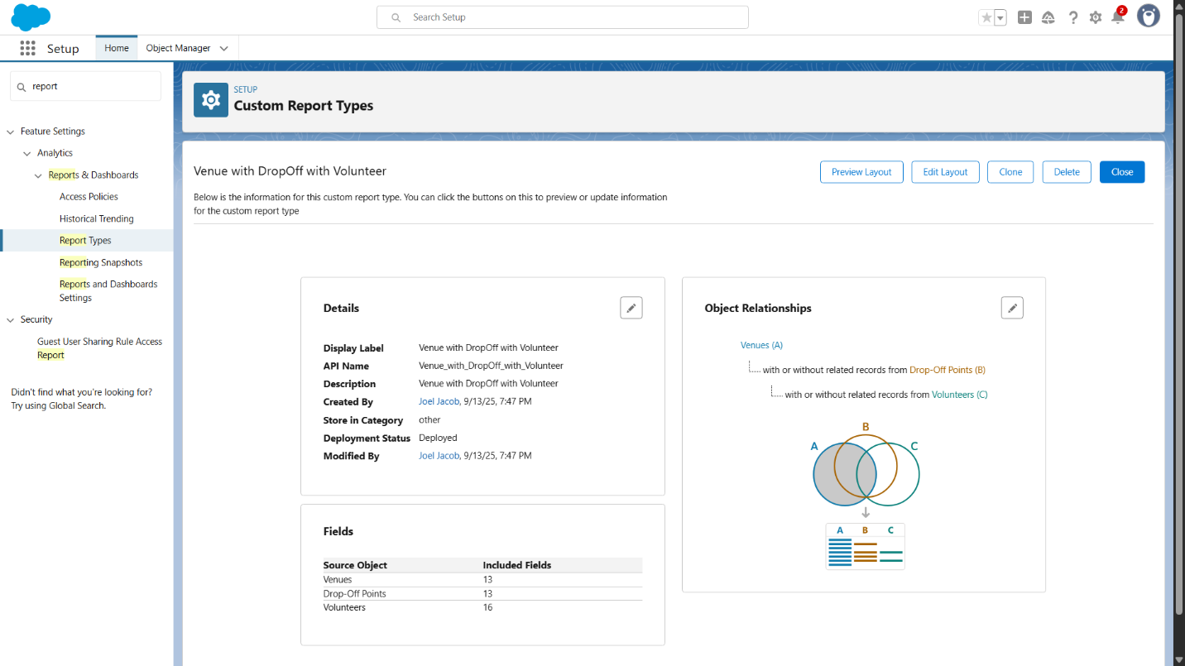

**11.Reports**

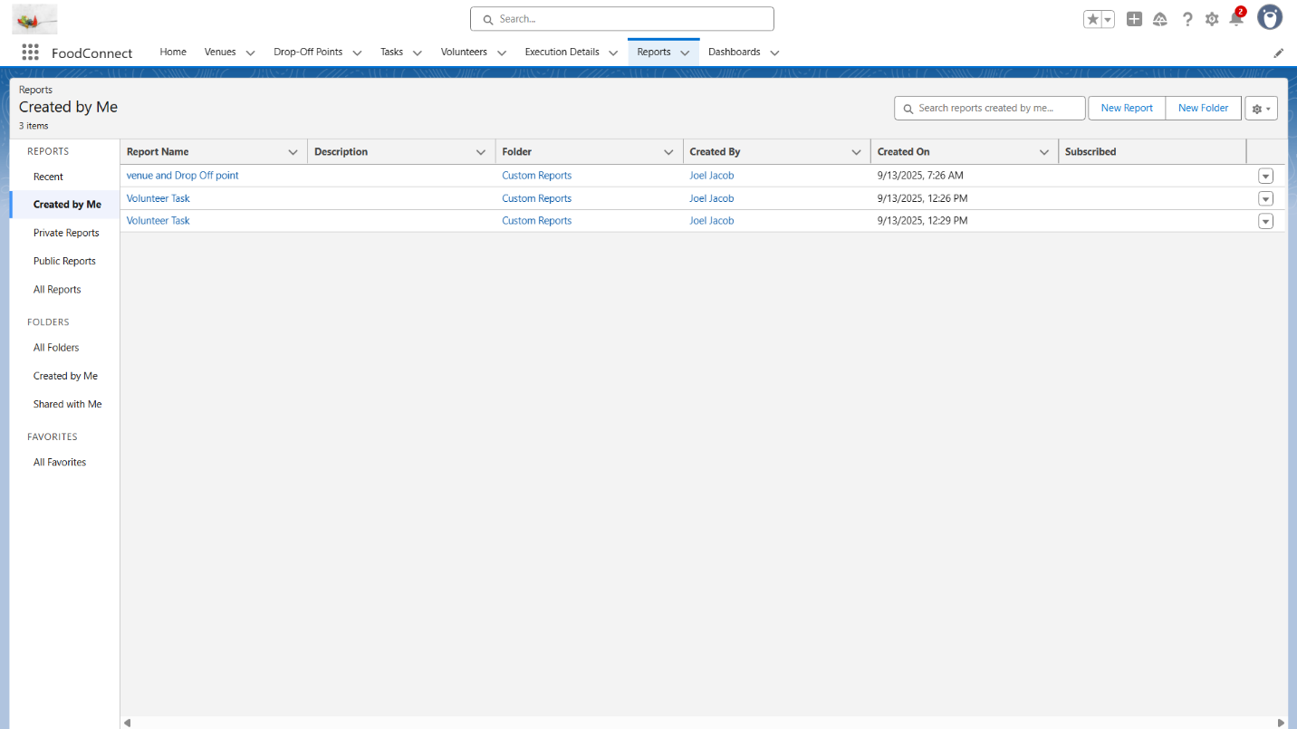

**12.Dashboard**

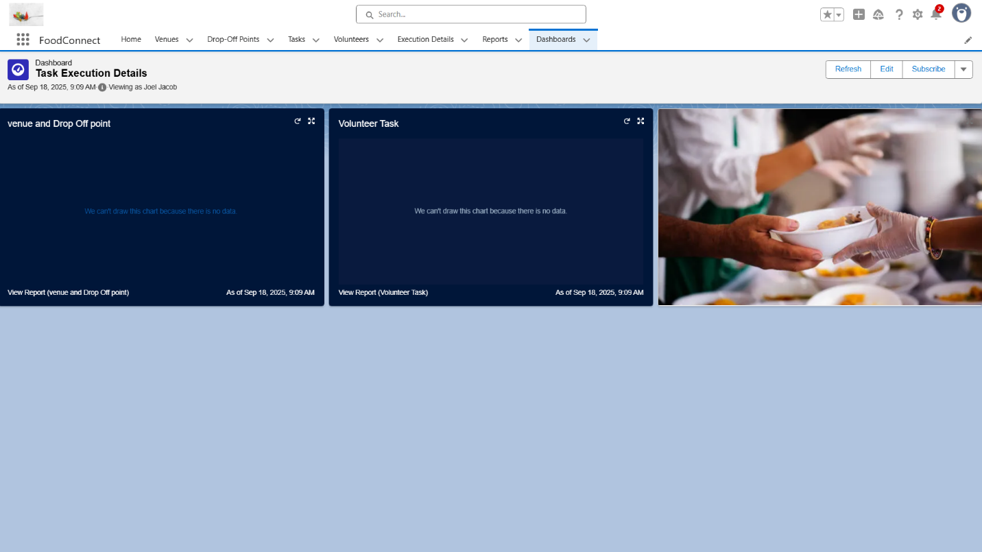

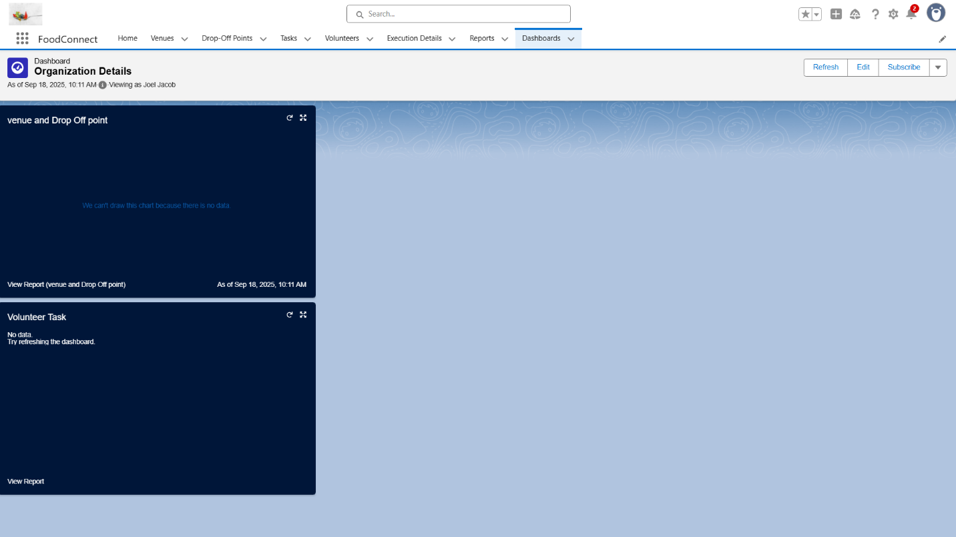

**13.Creation of Sharing Tools**

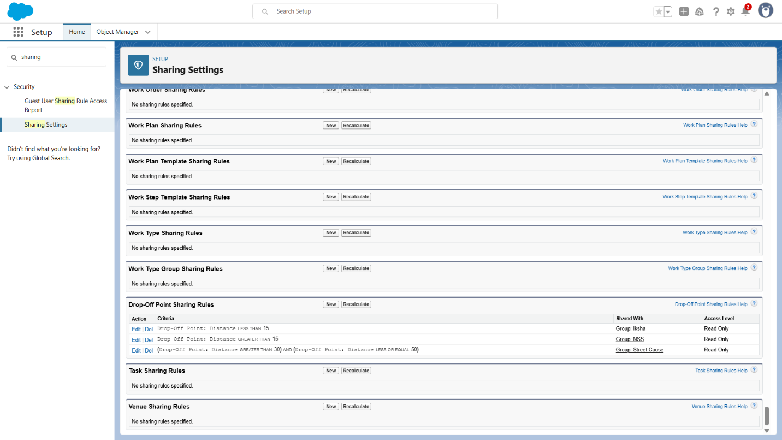

**14.Creation of Home Page**

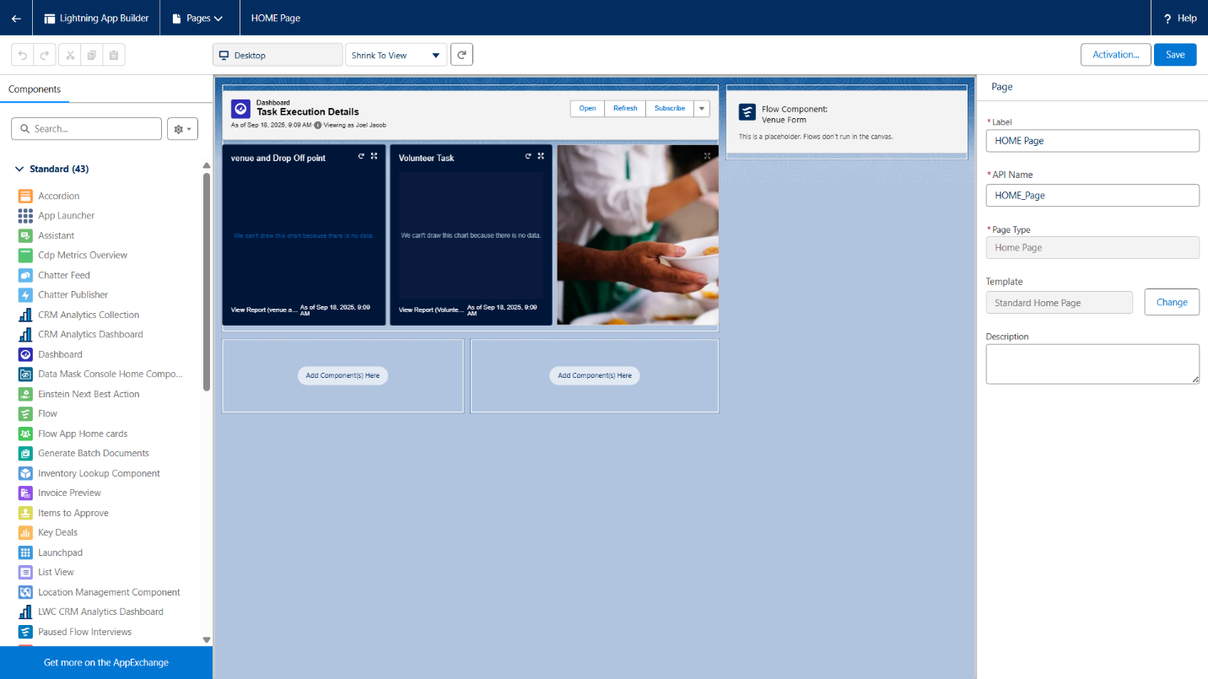

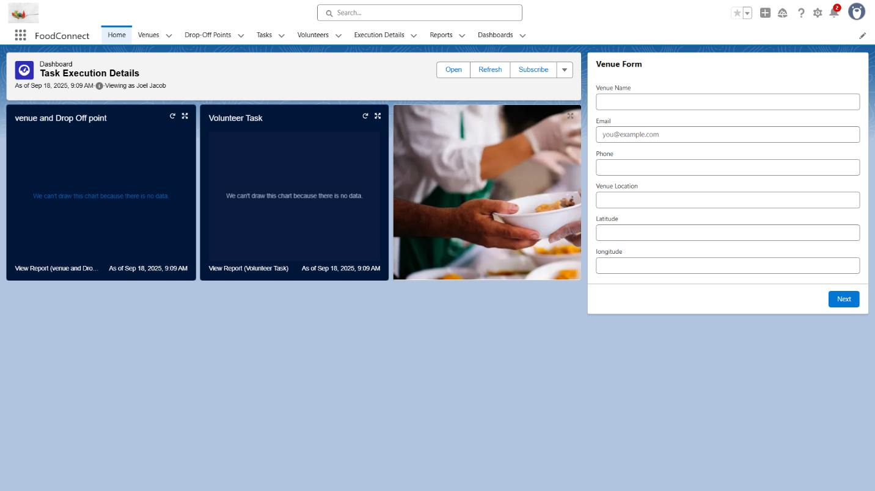

**Conclusion**

This project has shown how the Salesforce platform can be effectively used to build a transparent and efficient system for managing surplus food donations. By ensuring smooth coordination with volunteers, proper tracking of resources, and timely delivery to those in need, the solution not only helped reduce food wastage but also contributed to addressing hunger in a structured way.

The initiative, “To Supply Leftover Food to Poor Using Salesforce,” highlights the real-world impact of CRM technology when applied for social good, proving its ability to streamline processes and promote accountability.

**Key Achievements:**

* Simplified the collection and distribution of leftover food.
* Enabled real-time interaction among donors, volunteers, and NGOs.
* Implemented automation using custom objects, fields, Flows, and Apex triggers.
* Strengthened transparency through reports, dashboards, and role-based security.
* Enhanced user experience with customized Lightning App and Home Page.

**Student Outcomes:**

* Practical knowledge in Salesforce development and CRM customization.
* Stronger problem-solving through handling real-time operational challenges.
* Improved teamwork during requirement gathering, development, and testing.
* Exposure to professional tools, workflows, and project lifecycle practices.

**Future Enhancements**:

* Mobile integration for better accessibility to donors and volunteers.
* Use of AI and analytics to forecast demand and improve allocation.
* Wider collaboration with NGOs, hotels, and community kitchens.